# Practice Examination

QUESTION PAPER

Curriculum: **ACCP I17**

Subject: HTML 5

Exam Date:

**04/10/2017**

Total Marks: **20**

Duration: **90 minutes**

**MODUL TEST PRACTICAL**

**HTML 5**

***Note: You’re free to use either Dreamweaver, Notepad, Notepad++, Eclipse, Netbean, Visual Studio… etc. to do the exam. However, DO NOT use any external template, pre-made CSS / Javascript or Dreamweaver generated code in this exam. All HTML, CSS and Javascript must be coded manually.***

Question 1: [12]

Create a web page with name **home.html** and a file style sheet with name **style.css** as belows: *(****Note: using html5)***

* Body using background image “background.jpg”
* Page size is 960 pixel
* Header section:

+ Height:120px

+ Text-align: center

+ H1 tag insert content “Grey Junction” with font: arial, 300% and color: white

+ H2 tag insert content “Company Slogan Goes Here” with font: arial, 170% and color: white

* Menu section (nav):

+ Using background image “bar.jpg”, height:70px, text-align:center

+ Insert links: Home (home.html) and Contact Us (contact.html)

+ Color’s links are white, 14px, not underlined and padding:0px 20px.

+ When mouse hover the link, display underlined

* Advertisement section:

Insert image adv.jpg

* Content section:

+ Left column (width: 80%): insert content as show (file content.txt)

+ Right column (width:20%): insert content as show (file content.txt)

* Footer

+ Using background image “bar.jpg”, height:70px, text-align:center

+ Insert your name and email

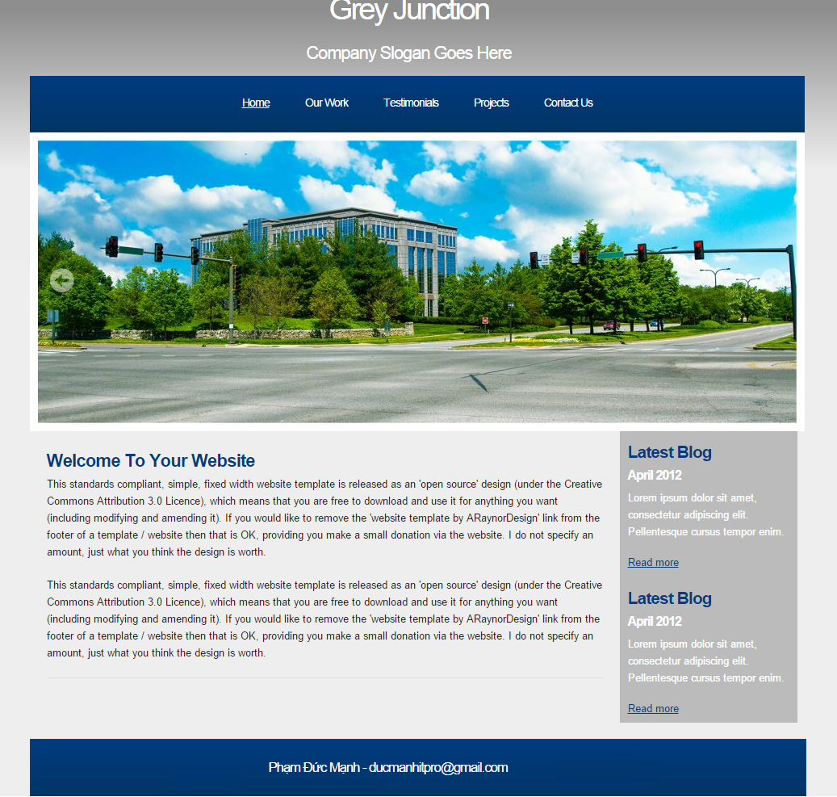

Question 2: [8]

Contact.html page with following form:

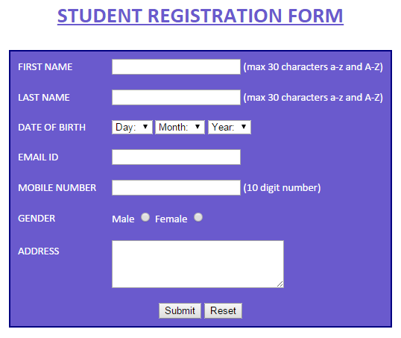

* Create a form as follows:

+ year of birth from 1980 to 2000

* When you click Submit, Validate the form as follows (using html5 attributes or javascript)

+ All the textbox is required

+ First name and last name is a maximum of 30 characters, including the letters a-z or A-Z

+ Email must only accept valid email address form. E.g.: example@mail.com

+ Telephone number must contain 10 digits